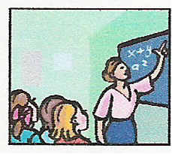
Teaching Professions Tech Prep
-----------------------------------------------------------------------------------------------
Field Experience Narrative – 25 points

Name: Click here to enter text. Date: Click here to enter a date.

Write a minimum one paragraph narrative (essay) about your field experiences this week. Include the times and days of your field experiences, as well as, the name of your mentor teacher(s). Discuss the activities with which you were involved and your role: Did you work alone, with other students, with the teacher, etc.? What was the classroom learning environment: one-on-one, small group, whole class, etc.? What did you observe: find interesting, strange or curious, difficult, fun, etc. about your field experience?
Click here to enter text.

